Retorikanalysemodel med eksempel.
Retorikanalyse laver vi især på taler, hvor det for taleren gælder om at overbevise andre om, at man har ret.
- Hvordan kan man besvare de 5 H’er (jvf Lasswell-modellen nedenfor). Hvem var taleren? Hvem talte han/hun til? (målgruppe/tilhørere – primære målgruppe (de, der umiddelbart er til stede eller de, der først ser det i TV, dvs den sekundære? (bredere befolkning/sociale lag). Hvad var budskabet (message)? Hvordan kommunikeres budskabet, så det går ind hos målgruppen?:
Gennem hvilken kanal (avis/TV/Internet)?
Og med hvilken effekt?
I en mere udbygget model vil man også se på budskabets indkodning (hvordan får det en sproglig og anden (gestus, mimik, layout, m.m.) iklældning, og afkodning (hvordan opfattes det i målgruppen?)
- Med hvilken troværdighed holdt taleren sin tale? Dette kaldes også etos – det er altså læsernes/publikums opfattelse af talerens pålidelighed
- Hvordan var talen opbygget/disponeret – start, mellemparti, konklusion, slut
- Hvordan var argumentationen (jvf argumentanalysen nedenfor)? Appellerede taleren til publikum ved hjælp af fakta og rationelle argumenter (logos), følelser (pathos) eller talerens troværdighed, herunder dennes egen blotte personlighed (ethos) – og hvor meget af hver?
- Hvordan var sproget? Var det klart, tydeligt, gentagelser eller metaforer (sprogbilleder)? Der kan være ”sprogblomster” (stærke billedlige metaforer).
- Hvordan passede talens sproglige stil til the mood (stemningen) – havde taleren sans for situationen, og hvad den krævede?
- Hvordan var talerens mimik. Blev der brugt gestus? Brugte taleren hænder og kropssprog (holdning og kropsudtryk)?
Argumentanalyse
De tre hoveddele i en argumentanalyse er påstand (claim), belæg (ground) og hjemmel(warrant).
- påstand: det synspunkt der fremføres og som afsenderen gerne vil have tilslutning til
- belæg: det der fremføres som støtte for påstanden
- hjemmel: den generelle regel der udgør grundlaget for at et bestemt belæg kan fremføres for en bestemt påstand.
Eksempel A : Der begås alt for mange mord i Chicago. Statistikker viser det. For mange amerikanere har et skydevåben….
Påstand (claim): Der begås alt for mange mord i Chicago
Belæg 1: Faktuelt argument (ground): Statistikker viser det. Belæg 2: Adgang til skydevåben for let
Hjemmel (Warrant): Norm/generel regel: Mordraten normalt ikke så høj i et højtudviklet samfund med veludviklet infrastruktur, og hvor borgernes behov i vidt omfang imødekommes. Hjemmelen kan også ses som en højere moralsk/etisk norm: Mord er forkasteligt. Det er forkeret at tage et andet menneskes liv.
Eksempel B: Arbejdsløsheden er for høj, og det skyldes den borgerlige regerings økonomiske politik.
Påstand (claim): Der er høj arbejdsløshed
Ground: Arbejdsløsheden skyldes den borgerlige regerings økonomiske politik.
Warrant: 1: Arbejdsløshed ”høj”, når den er over et vist niveau. 2: Når der er borgerlig regering, er det ikke arbejdsløshedsbekæmpelse, der har højst prioritet. 3: Etisk norm: Folk bør ikke være arbejdsløse. Alle skal have et arbejde.
Eksempler (fra: Obama tale om immigration, vedlagt nedenfor)
Sprogblomster: our immigration system is broken When I took office, I committed to fixing this broken immigration system (præsidenten som “mekaniker”)
Metafor: reaps the rewards (høster belønningen) You can come out of the shadows and get right with the law
Gentagelse: They work hard often in tough, low paying jobs. They support their families. They worship at our churches
logos: over the past six years deportations of criminals are up 80 percent (baseret på statistisk fact)
Pathos: let’s be honest, tracking down, rounding up and deporting millions of people isn’t realistic. Anyone who suggests otherwise isn’t being straight with you. It’s also not who we are as Americans (inclusive “we”). Millions of us, myself included, go back generations in this country, with ancestors who put in the painstaking work to become citizens this debate is about something bigger. It’s about who we are as a country and who we want to be for future generations. Are we a nation that accepts the cruelty of ripping children from their parents’ arms (her skrues op for patos: “rive børn ud af forældrenes arme” )
Ethos (øger troværdighed ved at bruge egen familie som eksempel): I’ve seen the courage of students who except for the circumstances of their birth are as American as Malia or Sasha. Det er også etos, når han etablerer forbindelse bagud til tidligere præsidenter: “As my predecessor, President Bush, once put it, they are a part of American life”. Det afgørende er ikke I denne sammenhæng, at han som democrat er ideologisk på et andet hold end Bush (fra Det republikanske Parti). Det afgørende er præsidentværdigheden og embedet som en historisk amerikansk institution.
Modsatte begrebspar/påstande (kontraster): “Felons (straffelovsovertrædere), not families. Criminals, not children. Gang members, not a mom who’s working hard to provide for her kids Are we a nation that accepts the cruelty of ripping children from their parents’ arms, or are we a nation that values families and works together to keep them together? Are we a nation that educates the world’s best and brightest in our universities only to send them home to create businesses in countries that compete against us, or are we a nation that encourages them to stay and create jobs here, We need more than politics as usual when it comes to immigration. We need reasoned, thoughtful, compassionate debate that focuses on our hopes, not our fears”
Påstand (claim): For more than 200 years, our tradition of welcoming immigrants from around the world has given us a tremendous advantage over other nations.
Belæg (ground): It’s kept us youthful, dynamic, and entrepreneurial. Warrant: As long as the immigration system is not broken
Udokumenterede påstande (claims without grounds): Americans are tired of gridlock. What our country needs right now is a common purpose, a higher purpose (pathos)
Argumentere ud fra, at man har tillagt modstanderen et synspunkt: And I believe it’s important that all of us have this debate without impugning each other’s character (hvorfor går I efter manden I stedet for efter bolden?)
Bruge et enkelt eksempel til at Knytte an til fælles grundværdier/fælles identitet (amerikansk drøm)/pathos: Over the past years I’ve seen the determination of immigrant fathers who worked two or three jobs without taking a dime from the government, and at risk any moment of losing it all just to build a better life for their kids
Retoriske spørgsmål, som tilhørerne ubevidst “besvarer”: Are we a nation that tolerates the hypocrisy of a system where workers who pick our fruit and make our beds never have a chance to get right with the law? Or are we a nation that gives them a chance…… - No, we’re not that kind of nation!!! (lægges der op til)
Narrativ med enkelteksempel for at skabe identification via fortælling af en hstorie( berettermodel): “ Now tomorrow I’ll travel to Las Vegas and meet with some of these students, including a young woman named Astrid Silva. Astrid was brought to America when she was 4 years old. Her only possessions were a cross, her doll, and the frilly dress she had on (her skrues op for patos – appel til tilhørernes følelser) ….When she started school, she didn’t speak any English. She caught up to other kids by reading”…..
Hvordan vil det videre gå Astrid ….. vi vil gerne høre mere….. Astrid bliver selve personificeringen af den amerikanske drøm, og Obama bygger en solidaritetsfortælling op omkring hende.
Er det følgende logos eller pathos (fact eller udokomenteret påstand): Our history and the facts show that immigrants are a net plus for our economy and our society . Her er rum for fortolkning, fortsat discussion og dermed politisk/ideologisk uenighed.
Reference til de højestefælles værdier (forfatning/religion): Scripture tells us, we shall not oppress a stranger, for we know the heart of a stranger. We were strangers once, too.
Vokabular (ordvalg): mange pronominer (personlige stedord) gør talen konkret og nærværende. Brug af inkluderende ”We” (appellerer til tilhørerne: Vi er sammen om dette!).

Simpel kommunikationsmodel:
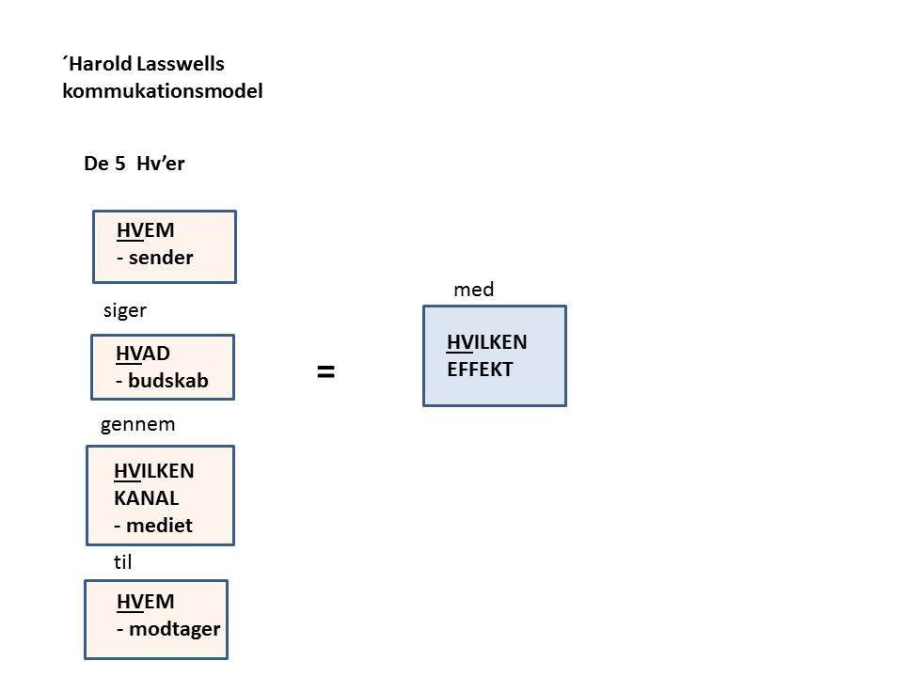

Lidt mere udvidet model:
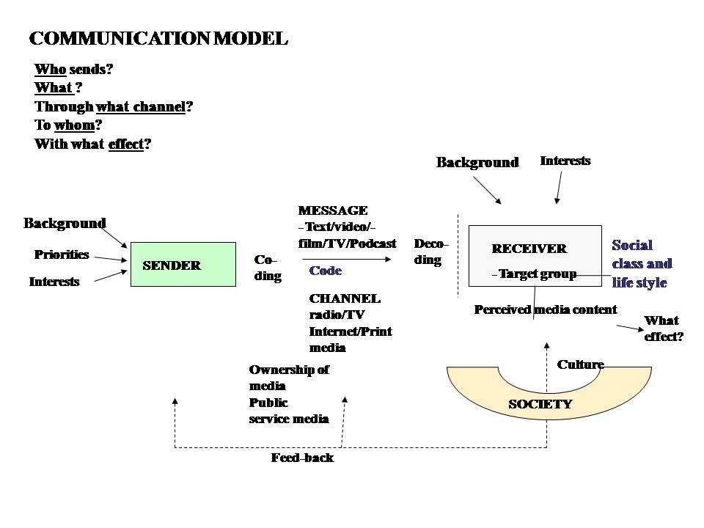

Transkript af hele Obamas tale:
A transcript of President Obama’s remarks on immigration..
OBAMA: My fellow Americans, tonight I’d like to talk with you about immigration. For more than 200 years, our tradition of welcoming immigrants from around the world has given us a tremendous advantage over other nations.
OBAMA: It’s kept us youthful, dynamic, and entrepreneurial. It has shaped our character as a people with limitless possibilities. People not trapped by our past, but able to remake ourselves as we choose.
But today, our immigration system is broken, and everybody knows it. Families who enter our country the right way and play by the rules watch others flout the rules. Business owners who offer their wages good wages benefits see the competition exploit undocumented immigrants by paying them far less. All of us take offense to anyone who reaps the rewards of living in America without taking on the responsibilities of living in America. And undocumented immigrants who desperately want to embrace those responsibilities see little option but to remain in the shadows, or risk their families being torn apart.

It’s been this way for decades. And for decades we haven’t done much about it. When I took office, I committed to fixing this broken immigration system. And I began by doing what I could to secure our borders.
Today we have more agents and technology deployed to secure our southern border than at any time in our history. And over the past six years illegal border crossings have been cut by more than half.
Although this summer there was a brief spike in unaccompanied children being apprehended at our border, the number of such children is actually lower than it’s been in nearly two years.
Overall the number of people trying to cross our border illegally is at its lowest level since the 1970s. Those are the facts.
Meanwhile, I worked with Congress on a comprehensive fix. And last year 68 Democrats, Republicans, and independents came together to pass a bipartisan bill in the Senate. It wasn’t perfect. It was a compromise. But it reflected common sense. It would have doubled the number of Border Patrol agents, while giving undocumented immigrants a pathway to citizenship, if they paid a fine, started paying their taxes and went to the back of the line. And independent experts said that it would help grow our economy and shrink our deficits.
Had the House of Representatives allowed that kind of bill a simple yes or no vote, it would have passed with support from both parties. And today it would be the law. But for a year and a half now Republican leaders in the House have refused to allow that simple vote. Now I continue to believe that the best way to solve this problem is by working together to pass that kind of common sense law. But until that happens, there are actions I have the legal authority to take as president, the same kinds of actions taken by Democratic and Republican presidents before me, that will help make our immigration system more fair and more just.
Tonight I’m announcing those actions.
OBAMA: First, we’ll build on our progress at the border with additional resources for our law enforcement personnel so that they can stem the flow of illegal crossings and speed the return of those who do cross over.
Second, I’ll make it easier and faster for high-skilled immigrants, graduates and entrepreneurs to stay and contribute to our economy, as so many business leaders proposed.
Third, we’ll take steps to deal responsibly with the millions of undocumented immigrants who already had live in our country.
I want to say more about this third issue, because it generates the most passion and controversy. Even as we are a nation of immigrants, we’re also a nation of laws. Undocumented workers broke our immigration laws, and I believe that they must be held accountable, especially those who may be dangerous.
That’s why over the past six years deportations of criminals are up 80 percent, and that’s why we’re going to keep focusing enforcement resources on actual threats to our security. Felons, not families. Criminals, not children. Gang members, not a mom who’s working hard to provide for her kids. We’ll prioritize, just like law e enforcement does every day.
But even as we focus on deporting criminals, the fact is millions of immigrants in every state, of every race and nationality still live here illegally.
And let’s be honest, tracking down, rounding up and deporting millions of people isn’t realistic. Anyone who suggests otherwise isn’t being straight with you. It’s also not who we are as Americans.
After all, most of these immigrants have been here a long time. They work hard often in tough, low paying jobs. They support their families. They worship at our churches. Many of the kids are American born or spent most of their lives here. And their hopes, dreams, and patriotism are just like ours.
As my predecessor, President Bush, once put it, they are a part of American life.
Now here is the thing. We expect people who live in this country to play by the rules. We expect those who cut the line will not be unfairly rewarded. So we’re going to offer the following deal: If you’ve with been in America more than five years. If you have children who are American citizens or illegal residents. If you register, pass a criminal background check and you’re willing to pay your fair share of taxes, you’ll be able to apply to stay in this country temporarily without fear of deportation. You can come out of the shadows and get right with the law. That’s what this deal is.
Now let’s be clear about what it isn’t. This deal does not apply to anyone who has come to this country recently. It does not apply to anyone who might come to America illegally in the future. It does not grant citizenship or the right to stay here permanently, or offer the same benefits that citizens receive. Only Congress can do that. All we’re saying is we’re not going to deport you.
I know some of the critics of the action call it amnesty. Well, it’s the not. Amnesty is the immigration system we have today. Millions of people who live here without paying their taxes or playing by the rules, while politicians use the issue to scare people and whip up votes at election time. That’s the real amnesty, leaving this broken system the way it is. Mass amnesty would be unfair. Mass deportation would be both impossible and contrary it to our character.
What I’m describing is accountability. A common sense middle- ground approach. If you meet the criteria, you can come out of the shadows and get right with the law. If you’re a criminal, you’ll be deported. If you plan to enter the U.S. illegally, your chances of getting caught and sent back just went up.
The actions I’m taken are not only lawful, they’re the kinds of actions taken by every single Republican president and every single Democratic president for the past half century.
And to those members of Congress who question my authority to make our immigration system work better or question the wisdom of me acting where Congress has failed, I have one answer: Pass a bill. I want to work with both parties to pass a more permanent legislative solution. And the day I sign that bill into law, the actions I take will no longer be necessary.

OBAMA: Meanwhile, don’t let a disagreement over a single issue be a deal breaker on every issue. That’s not how our Democracy works, and Congress shouldn’t shut down our government again just because we disagree on this.
Americans are tired of gridlock. What our country needs right now is a common purpose, a higher purpose. Most Americans support the types of reforms I’ve talked about tonight, but I understand with the disagreements held by many of you at home.
Millions of us, myself included, go back generations in this country, with ancestors who put in the painstaking work to become citizens. So we don’t like the notion anyone might get a free pass to American citizenship.

I know some worry immigration will change the very fabric of who we are, or take our jobs, or stick it to middle-class families at a time they already feel they’ve gotten a raw deal for over a decade. I hear those concerns, but that’s not what these steps would do.

Our history and the facts show that immigrants are a net plus for our economy and our society. And I believe it’s important that all of us have this debate without impugning each other’s character.
Because for all the back and forth in Washington, we have to remember that this debate is about something bigger. It’s about who we are a country and who we want to be for future generations.
Are we a nation that tolerates the hypocrisy of a system where workers who pick our fruit and make our beds never have a chance to get right with the law? Or are we a nation that gives them a chance to make amends, take responsibility, and give their kids a better future?
Are we a nation that accepts the cruelty of ripping children from their parents’ arms, or are we a nation that values families and works together to keep them together? Are we a nation that educates the world’s best and brightest in our universities only to send them home to create businesses in countries that compete against us, or are we a nation that encourages them to stay and create jobs here, create businesses here, create industries right here in America? That’s what this debate is all about.
We need more than politics as usual when it comes to immigration. We need reasoned, thoughtful, compassionate debate that focuses on our hopes, not our fears. I know the politics of this issue are tough, but let me tell you why I have come to feel so strongly about it. Over the past years I’ve seen the determination of immigrant fathers who worked two or three jobs without taking a dime from the government, and at risk any moment of losing it all just to build a better life for their kids. I’ve seen the heartbreak and anxiety of children whose mothers might be taken away from them just because they didn’t have the right papers. I’ve seen the courage of students who except for the circumstances of their birth are as American as Malia or Sasha, students who bravely come out as undocumented in hopes they could make a difference in the country they love.
Kilde: Washington Post Nov 20 2014: http://www.washingtonpost.com/politics/transcript-obamas-immigration-speech/2014/11/20/14ba8042-7117-11e4-893f-86bd390a3340_story.html

